 | Rank | Insignia | Cap Badge | Abbreviation | Address as |  | Refer to |  | Saluted
 |  |  |  |  | Senior | Subordinate | In speech | In writing | Saluted
ATC/CCF (RAF) | Cadet♠ | - | 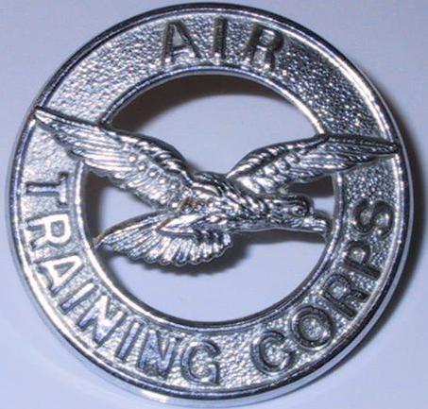  (ATC)  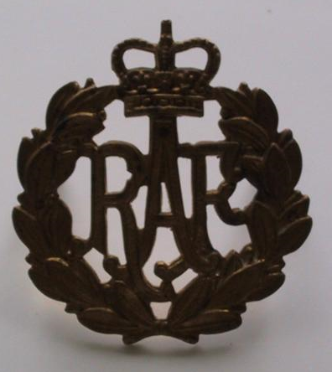  CCF (RAF) | Cdt♠ | - | Cadet♠ | Cadet♠ | Cadet♠ X | ✗
ATC/CCF (RAF) | Lance Corporal♥ |  |  | Cdt LCpl | Lance Corporal | Lance Corporal | Lance Corporal | Lance Corporal X | ✗
ATC/CCF (RAF) | Cadet Corporal♠ |  |  | Cdt Cpl♠ | Corporal*♠ | Corporal*♠ | Corporal*♠ | Cadet Corporal♠ X | ✗
ATC/CCF (RAF) | Cadet Sergeant♠ |  |  | Cdt Sgt♠ | Sergeant*♠ | Sergeant*♠ | Sergeant*♠ | Cadet Sergeant♠ X | ✗
ATC/CCF (RAF) | Cadet Flight Sergeant♠ |  |  | Cdt FS♠ | Flight Sergeant*♠ | Flight Sergeant*♠ | Flight Sergeant*♠ | Cadet Flight Sergeant♠ X | ✗
ATC/CCF (RAF) | Cadet Warrant Officer♠ | 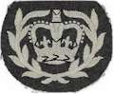 |  | CWO♠ | Warrant Officer*♠ | Warrant Officer*♠ | Warrant Officer*♠ | Cadet Warrant Officer♠ X | ✗
ATC/CCF (RAF) | Civilian Instructor | - | - | CI | Sir/Ma’am | Mr/Mrs/Miss | Mr/Mrs/Miss | Civilian Instructor X | ✗
ATC/CCF (RAF) | Civilian Gliding Instructor | - | - | CGI | Sir/Ma'am | Mr/Mrs/Miss | Mr/Mrs/Miss | Civilian GlidingInstructor X | ✗
ATC/CCF (RAF) | Chaplain | - | - | Chaplain | Padre | Padre | Padre | [Title eg Reverend] X | ✗
ATC/CCF (RAF) | Sergeant (ATC) |  |  | Sgt (ATC) | Sergeant | Sergeant | Sergeant | Sergeant (ATC) X | ✗
ATC/CCF (RAF) | Flight Sergeant (ATC) |  |  | FS (ATC) | Flight Sergeant | Flight Sergeant | Flight Sergeant | Flight Sergeant (ATC) X | ✗
ATC/CCF (RAF) | Warrant Officer (ATC) |   or   | 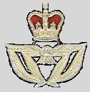 | WO (ATC) | Sir/Ma’am | Mr/Mrs/Miss | Mr/Mrs/Miss | Warrant Officer (ATC) X | ✗
RAF VR(T) | Officer Cadet |  | 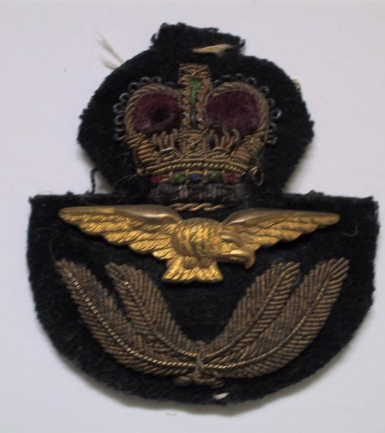 | OCdt | Sir/Ma’am | Mr/Mrs/Miss | Mr/Mrs/Miss | Pilot Officer X RAF VR(T) | ✓
RAF VR(T) | Pilot Officer |  |  | Plt Off | Sir/Ma’am | Mr/Mrs/Miss | Mr/Mrs/Miss | Pilot Officer X RAF VR(T) | ✓
RAF VR(T) | Flying Officer |  |  | Fg Off | Sir/Ma’am | Mr/Mrs/Miss | Mr/Mrs/Miss | Flying Officer X RAF VR(T) | ✓
RAF VR(T) | Flight Lieutenant |  |  | Flt Lt | Sir/Ma’am | Flight Lieutenant | Flight Lieutenant | Flight Lieutenant X RAF VR(T) | ✓
RAF VR(T) | Squadron Leader | 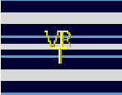 |  | Sqn Ldr | Sir/Ma’am | Squadron Leader | Squadron Leader | Squadron Leader X RAF VR(T) | ✓
RAF VR(T) | Wing Commander |  |  | Wg Cdr | Sir/Ma’am | Wing Commander | Wing Commander | Wing Commander X RAF VR(T) | ✓
RAF | RAF SNCO, Warrant Officer and Officer ranks are to be addressed as and referred to in the same fashion as ATC/VR(T) equivalents, with ‘RAF’ in place of ‘ATC’ or ‘RAF VR(T)’ where appropriate, with the following exceptions:
RAF | Officer Cadet (RAF) | Various |  | OCdt | Sir/Ma’am | Mr/Mrs/Miss | Mr/Mrs/Miss | Officer Cadet (RAF) X | ✗
RAF | Officer Cadet (UAS) |  |  | OCdt | Sir/Ma’am | Mr/Mrs/Miss | Mr/Mrs/Miss | Officer Cadet (RAF VR UAS) X | ✗
RAF | Aircraftman♣ | - |  | AC | Staff | Aircraftman | Aircraftman | Aircraftman X | ✗
RAF | Leading Aircraftman♣ |  |  | LAC | Staff | Leading Aircraftman | Leading Aircraftman | Leading Aircraftman X | ✗
RAF | Senior Aircraftman♣ |  |  | SAC | Staff | Senior Aircraftman | Senior Aircraftman | Senior Aircraftman X | ✗
RAF | Senior Aircraftman♣ Technician |  |  | SAC(T) | Staff | Senior Aircraftman | Senior Aircraftman | Senior Aircraftman Technician X | ✗
RAF | Junior Technician⁺ |  |  | JT | Staff | Junior Technician | Junior Technician | Junior Technician X | ✗
RAF | Lance Corporal^{Ω} |  |  | LCpl | Lance Corporal | Lance Corporal | Lance Corporal | Lance Corporal (RAF) X | ✗
RAF | Corporal |  |  | Cpl | Corporal | Corporal | Corporal | Corporal (RAF) X | ✗
RAF | Chief Technician |  |  | Chf Tech | Chief Technician | Chief Technician | Chief Technician | Chief Technician X | ✗
RAF | Master Aircrew♦ |  |  | MAcr | Sir/Ma’am | Mr/Mrs/Miss | Mr/Mrs/Miss | Master Aircrew X | ✗
* Can be prefixed with the word ‘Cadet’ in speech if needed to distinguish from adult staff ranks
♥ CCF only
✪ The word 'Lance' may be omitted in informal speech, ie Lance Corporals may simply be addressed as 'Corporal'.
♠ Over 18 year old cadets in the ATC are prefixed by the word Staff in writing, or the letter ‘S' for abbreviations, e.g. Staff Cadet Flight Sergeant X or SCdt FS X.
♣ Or Aircraftwoman.
^{Ω} RAF Regiment only
♦ Known by speciality, e.g. Master Air Loadmaster
⁺ No more promotions are being made to JT as of 2005, current JTs will remain at that rank until promotion, demotion or retirement
X Indicates position of name when full name and rank is written down AL1

