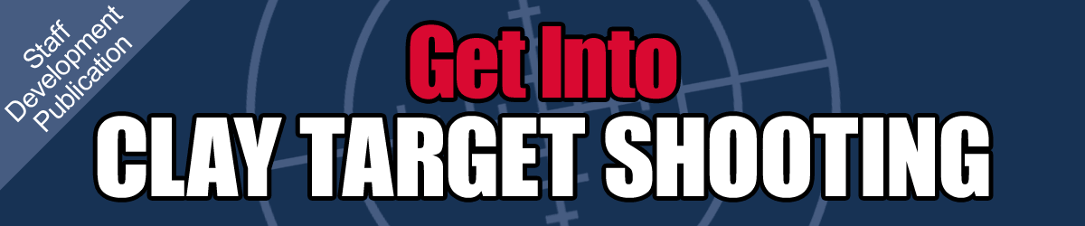
April 2013 | Air Cadet Central Edition

This guide is intended as a handy summary and a starting point for further research into a subject.
Always consult current official policy before undertaking training.

Clay target shooting is an authorised cadet activity run under the  civilian Clay Pigeon Shooting Association (CPSA) rules.  This means that you do not require the normal shooting qualifications required by Pam 21-C (eg. SA(SR)07 or SAAI).  Current policy can be found in a letter from HQ Land Forces. | In this guide:  1. Courses and qualifications  2. Equipment and costs  3. Competitions  4. Summary

1. Courses and qualifications
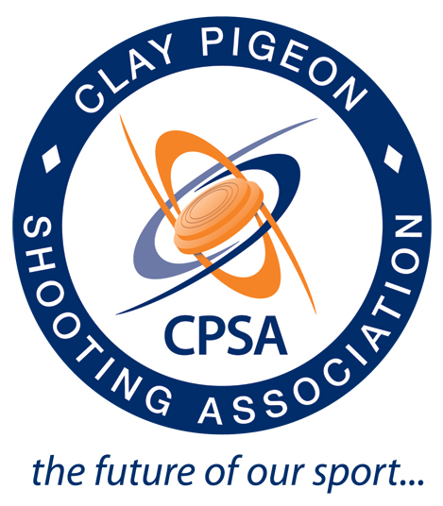 | The CPSA runs its own courses which enable you to become competent in shotgun handling, running a clay target range and coaching technique.  To get started, you need to attend a Shotgun Skills Course (1 day) to gain your basic proficiency in handling shotguns and elementary shooting technique.  This is then followed by a Safety Officers Course (1 day) which entitles you to run a clay target range. Note that this qualification does not allow you to ‘coach’ to improve technique, it only allows you to safely run a range.

Completion of an Instructor Development Workshop (1 day) makes you eligible to attend a Level 1 Instructor Course (5 days), which allows you to coach technique.  The Army Rifle Association (ARA) runs a variety of courses which are open to all CFAVs and are very competitively priced. Course dates are published annually in a Defence Instructional Notice (DIN) which your WHQ should be able to obtain for you. | 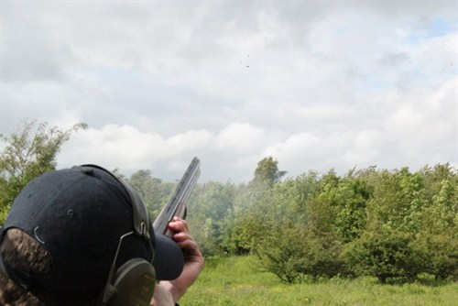

2. Equipment and costs  To get started you will need a budget of between £1500 and £2000.  This will allow you to purchase:  - A good-quality single-stack electric clay target trap.  - This avoids safe handling issues associated with manual traps.  - One or two shotguns (normally second hand).  - PPE such as glasses/caps.  - Cleaning kit.  - A starting box of clays.  - Ammunition.  You can spend more, and get more capability, but this is a typical basic setup cost. A reasonable condition 12-bore shotgun can be had for around £500.  Squadrons purchasing shotguns must do so under Non-Service Weapons arrangements, which includes a requirement for annual servicing.  The Corps SME on Clay Target shooting is Flt Lt Allan White, who is part of the Corps Shooting Development Team (Clay Target). | 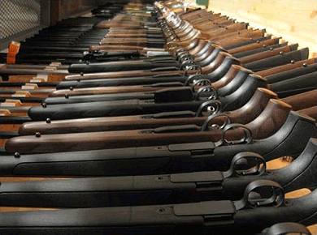  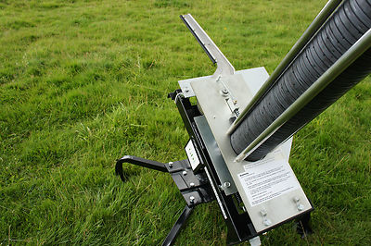  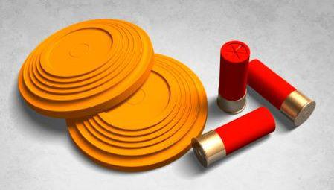

3. Competitions
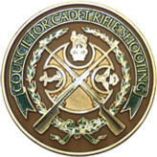 | A cadet Clay Target Shooting competition is held annually as an inter-service match against the Sea Cadets and Army Cadets. Teams consist of 4 cadets of any gender who can demonstrate that they have passed the Shotgun Handling Test (delivered by CPSA safety officers). Costs are in the region of £100 per team of 4, plus messing contributions.  Competition details are published annually by the Council For Cadet Rifle Shooting

4. Summary
Attend Shotgun Skills course.
Attend Safety Officer course.
Raise funds and obtain your equipment.
Locate a CPSA or MOD shotgun range.
Train your cadets in shotgun handling.
Go shooting!

LF/PSC/Cadets1001 dated 25 October 2011: Policy for Clay Target Shooting by Cadets.
LF/PSC/Cadets1001 dated 25 October 2011: Policy for Clay Target Shooting by Cadets. Enclosures 1-4.
ACP 26: Security Of Arms And Ammunition (Restricted).
80/21 dated 7 February 2013: National Cadet Clay Target Shooting Championships 2013.
2013DIN10-002

