May 2013 | Air Cadet Central Edition

This guide is intended as a handy summary and a starting point for further research into a subject.
Always consult current official policy before undertaking training.

Fieldcraft training is a core ACO activity. Its main purpose is to train cadets to live and work effectively in a field environment.It offers opportunities to develop cadets’ leadership, communications, navigation and First Aid skills.  The syllabus for fieldcraft training is laid down in the Air Cadet Fieldcraft Training Instructions, with the material available on Ultilearn. The lessons are provided as slide presentations, but can be delivered without the slides as long as the content and sequence remain the same. | In this guide:  1. Syllabus  2. Qualifications  3. Admin and approval  4. Military Skills and Tactics

1. Syllabus
- Preparation and Packing of Personal Equipment  - Admin in the Field  - The 2-man shelter  - Why Things are Seen  - Personal Camouflage and Concealment  - Observation  - Judging Distance  - Indications of Targets  - Range Cards | - Duties of a Sentry  - Movement in the Field by Day  - Field Signals  - Elementary Obstacle Crossing  - Selecting a Route Across Country  - Stalking  - Introduction to Night Training  - Elementary Night Movement  - Harbour Drills

2. Qualifications
Fieldcraft training is to be conducted by Authorised Instructors (AI), who know the subject and have the knowledge and experience to deliver it. Formal qualifications are not required, other than the completion of any course which includes an element of instructional technique.

For deployed exercises (see below) a qualified Exercise Conducting Officer is required. This is a two-day course which is required to be renewed every four years, with a ‘currency check’ every two years. If an exercise requires multiple ECOs then a Detachment Commander is to be in charge, he or she must be an RAFVR(T) officer.

May 2013 | Get Into FIELDCRAFT | ACC Edition

3. Admin and approval  Local training done on squadron premises or the extended squadron footprint (ESF) must be risk assessed (generic RAs are provided), and only the Squadron Commander’s approval is needed. | 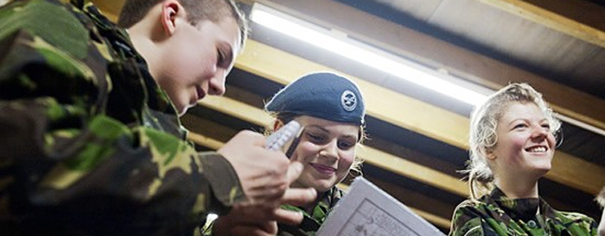

Training that takes place off squadron premises is categorised as a Deployed Exercise (DE).

- FT activities in daylight and lasting no longer than 8 hrs are to be approved at Wg level by the WgFTO.
- Static FT camps of up to 72 hrs and involving a maximum of 30 cadets are to be approved by OC Wgs provided no night exercises, or improvised camping, are involved.
- Other Fieldcraft Activities. The Rgnl HQ (normally the RFTO) is to provide final approval for DEs that include any of the following:
  - Night exercises.
  - Improvised overnight camping.
  - Duration Over 72 hours.
  - 30+ cadets.

For both BDEs and ADEs, a uniformed CFAV is required as the Exercise Controller (EC), and the following documentation must be produced and approved:

- Admin Instruction, including:
  - Main Events List (MEL);
  - Map; and
  - Exercise Trace (map overlay showing boundaries, routes and locations)
- Exercise Action and Safety Plan (EASP)
- Approval to use the land for fieldcraft training: either
  - Defence Training Estate (DTE) booking; or
  - Training Over Private Land (TOPL) approval.
- Risk assessment

A qualified Activities First Aider must be present. The ratio of staff to cadets is a maximum 1:8 for fieldcraft training.

4. Military Skills and Tactics
Military Skills and Tactics may be taught and exercised on approved courses only, including Junior Leaders, Cadet Leadership Courses at Frimley Park or Nesscliffe, and RAF Regiment work experience.

These courses may include section battle drills, patrolling and ambushes, operations in built-up areas (OBUA) and other areas of military skills and tactics, which are taught to develop leadership skills.

ACFTI No 1
ACFTI No 5
ACFTI No 2
ACFTI No 1

