April 2014 | Air Cadet Central Edition

This guide is intended as a handy summary and a starting point for further research into a subject.
Always consult current official policy before undertaking training.

First aid training in the ACO is conducted in partnership with the British Heart Foundation (BHF) and St John Ambulance (SJA). Training is available to cadets and staff at several different levels.  First aid cover is required for most cadet activities, and provides useful skills  and qualifications for cadets and staff. | In this guide:  1. Heartstart  2. Youth First Aid  3. Activity First Aid

1. Heartstart
Heartstart is an initiative co-ordinated by the BHF to teach members of the public what to do in a life-threatening emergency: “simple skills that save lives”.  It can be delivered in a minimum of 2 hours, but is usually delivered over two parade nights to give participants time to practice. It is divided into two stages: | 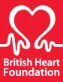
- Stage 1 develops practical skills including the recovery position, and performing CPR.
- Stage 2 looks at heart attack signs and symptoms, choking, and serious bleeding.
- A short additional (optional) module covers the use of Automated External Defibrillators (AEDs).
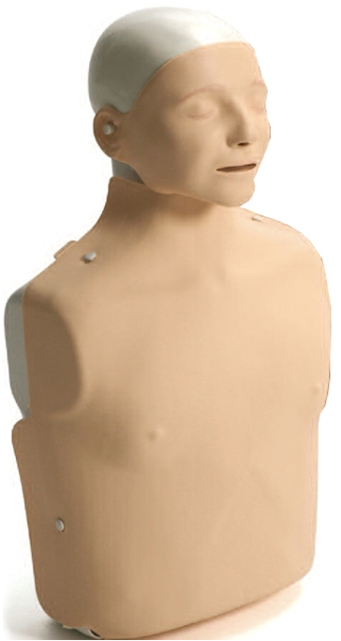 | There is no formal assessment and certificates are awarded for attendance.  To run the course, you must be a qualified Heartstart instructor. This process varies so contact your Wing First Aid Officer for more details (if you are qualified to instruct YFA, it’s likely that you will be able to run Heartstart with minimal extra training).  The BHF provides training resources including a ‘Buying Time’ DVD that covers the main topics. They also provide training manikins (‘Resusci Annes’) and a limited supply of consumables (lungs, wipes etc.) Your Wing First Aid Officer should have more information.

Competitions
First aid competitions are usually held at Wing and Region Competition Days. Teams and individuals are judged on their response to a variety of first aid scenarios, which may include realistic casualty simulations, props and multi-casualty scenes.

April 2014 | Get Into FIRST AID | ACC Edition

2. Youth First Aid

Successful completion of a Youth First Aid (YFA) course entitles cadets to wear the red YFA badge on their brassard. It requires a minimum of  12 hours to teach and assess, but is usually delivered as a 2-day weekend course or spread across several parade nights.  ACTO 8 specifies a minimum instructor to student ratio of 1:12, and a minimum assessor to student ratio of 1:6. Assessors “must not have any input to the training of the cadets being assessed”, and must hold an accepted First Aid qualification. | 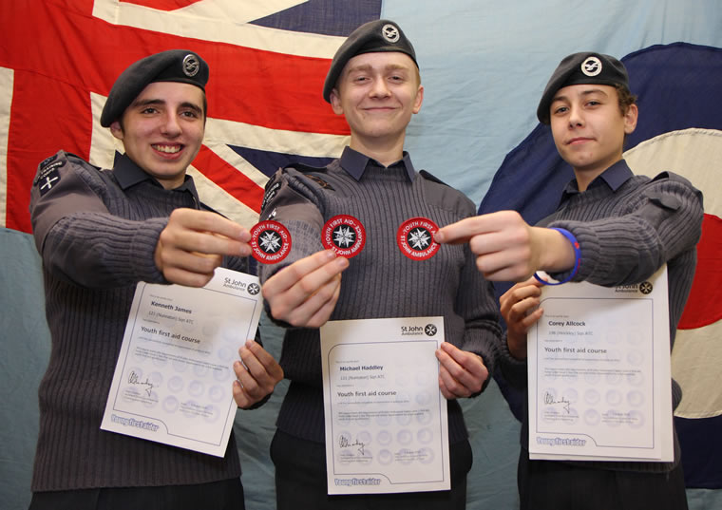

The YFA syllabus covers the following topics: (topics marked with ✱ are formally assessed)

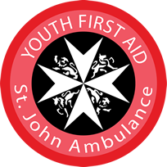 | - Asthma  - Bites and stings  - Bleeding (minor)  ✱ Bleeding and shock  - Bone, muscle and joint injuries  - Burns and scalds  - Chest pains  - Choking | - Communication and casualty care  - Coping in an emergency  - Electric shock  - Fainting  - First aid kit  - Foreign objects  - Head injuries  - Heat exhaustion | - Hypothermia  - Low blood sugar  - Poisons  ✱ Primary survey  ✱ Recovery position  ✱ Resuscitation  - Seizures  - Severe allergic reaction  - Spinal injury

3. Activity First Aid

AFA holders can provide the minimum permitted level of first aid cover for cadets at most activities,​. The qualification also allows instructor cadets and staff to teach and assess the YFA syllabus.  AFA takes a minimum of 16 hours to teach and assess, and is usually delivered as a weekend course at wing level. AFA is a nationally-recognised qualification, but is separate and unrelated to First Aid At Work (FAAW). Trainers and assessors must be recognised and registered with SJA. | 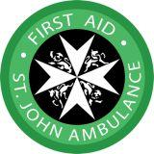

The next steps...
- Contact your  Wing FA Officer | - Attend an AFA course  - YFA & HS course training | - Organise / assist with  YFA & HS courses!

Some wings organise the BTEC Level 3 Award in Education and Training (formerly PTTLS) course in conjunction with First Aid training. Some wings also provide further FA training, including casualty simulation, FAAW or EAD courses.

Delivering the training across several parade nights allows it to count towards a cadet’s DofE Award skills section.
ACTO 8, para. 15.
ACTO 8, Annex B.
ACTO 26, para. 5.
JSP 535 (Cadet Training Safety Precautions), Part II (Training Safety), para. 108.
PAM 21C, chapter 2, section 2, para. 232.

