January 2015 | Air Cadet Central Edition

This guide is intended as a handy summary and a starting point for further research into a subject.
Always consult current official policy before undertaking training.

Target shooting is one of the core activities of the ATC.  Cadets are permitted to fire:  - Air rifles (0.177” only)  - No. 8 Rifle and other 0.22” rifles  - L98A2 Cadet General Purpose Rifle  - L81A2 Cadet Target Rifle  - L86A2 Light Support Weapon  - Shotgun (run as a sport, see supplementary guide) | In this guide:  1. Skill at Arms instruction  2. Range management  3. Marksmanship awards  4. Competitions

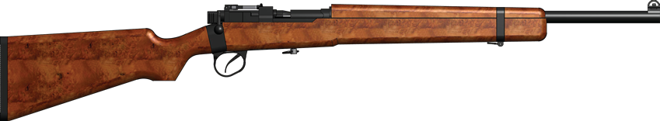  No. 8 Rifle  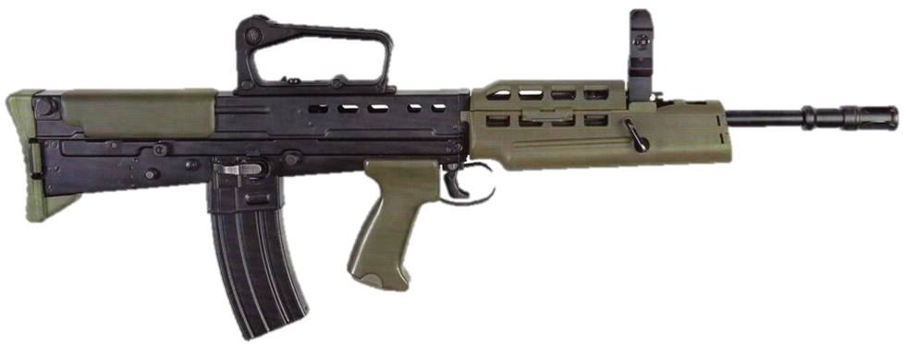  L98A2  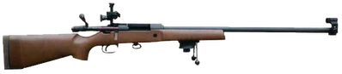  L81A2 | To be allowed to shoot, cadets must:  - Meet the eligibility criteria (eg. minimum age, previous experience).  - Have passed the relevant Weapon Handling Test (WHT) within 6 months.  Skill at Arms Instructors (SAAI) instruct Skill at Arms and conduct WHTs.  At least one Range Conducting Officer (RCO) and Safety Supervisor are required to run a live firing practice at a range, depending on the range type.  Cadet Force Adult Volunteers (CFAV) must have been Counter Terrorism Checked (CTC) before they can be awarded any of the qualifications mentioned in this guide.  Courses are run by regional Small Arms Training Teams (SATTs) or CTT (Central Training Team). Contact your Wing Shooting Officer for application instructions.

1. Skill at Arms instruction
Skill at Arms (SAA) instruction covers the following elements:  - Initial Weapon Training is the first occasion on which an individual is taught the basic skills for a particular weapon.  - Practice periods are to develop the skills of cadets who have already been taught the basic skills for a particular weapon.  - Weapon Handling Tests allows an individual’s proficiency to be assessed before live firing.  Skill at Arms Instructor is often abbreviated to SAAI.  SAAIs must hold current WHTs for the weapons they want to instruct on. | 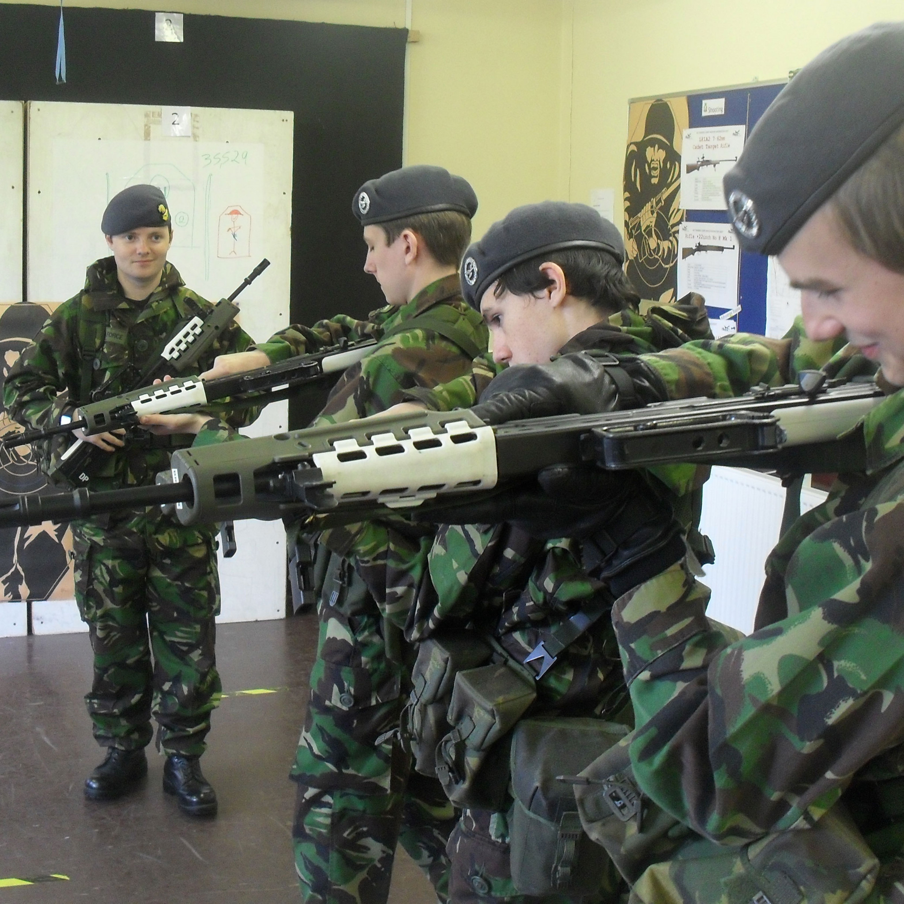

April 2013 | Get Into SHOOTING | ACC Edition

2. Range management
Live firing marksmanship training (LFMT) is conducted by a  Range Conducting Officer (RCO).  Different types of ranges (eg. tube, gallery) have different Ancillary Range Duties (ARD), which include:  - Safety Supervision (all types of range)  - Butts control (some types of range)  - Console supervision (some types of range)  On indoor ranges with 2 firers or less, subject to various conditions, the RCO can also act as the Safety Supervisor, removing the need for a second qualified CFAV . | 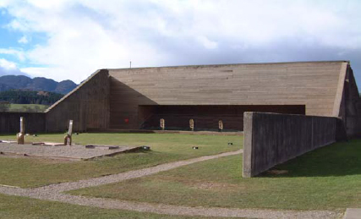  25 metre barrack range
Range management qualifications allow the holder to conduct LFMT and include:
- SA(SR)07 allows the holder to be an RCO on most types of short range (eg. tube or barrack range).
- SA(LR)07 allows the holder to be an RCO on most types of long range (eg. gallery range).
- The above qualifications both allow the holder to conduct ARD on most types of range.
- DCCT Basic Operator allows the holder to use Dismounted Close Combat Trainer (DCCT) facilities.
CFAVs can attend an ARD course and become authorised to conduct ARD on most types of range.
3. Marksmanship awards
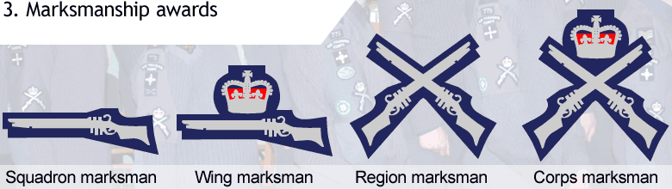
Cadets are awarded marksmanship badges (worn on the brassard) for passing marksmanship tests.

4. Competitions
Air Rifle | Small Bore | Full Bore
Commonwealth Matches  Air Rifle Postal League | Battle of Britain Challenge Cup  Punch and Shell Competitions  WJ Taylor Small Bore Competition  Country Life Small Bore Comp.  Commonwealth Competitions | Inter-Service Cadet Rifle Meeting  Pre-Bisley Competition  Cadet Inter-Service Skill at Arms Meeting (CISSAM)  Commonwealth Competitions
Many wings also run their own inter-Squadron postal competitions.

ACTO 43, paras 22-41.
Pam 21-C, chapter 4, sections 5-12.
Pam 5-C, chapter 5.
Pam 21-C, chapter 4, sections 5-12.
Pam 21-C, chapter 2, section 2, paragraphs 0119-0123.
Pam 21-C, chapter 1, section 3.
ACTO 48.
ACTO 43, para. 3.
ACTOs 45-47.
Pam 21-C, paragraphs 04441 (Air Rifle), 04136 (Indoor Ranges) and 04155 (Tube and Enclosed Ranges).

