Exercise Accumulate
    - Pre-requisites. This is an outdoor, first-class cadet consolidation exercise, requiring the full teaching of the following subjects:
      - Radio communications
      - Map reading
      - HeartStart
      - The Royal Air Force
      - Initial expedition training
      - Basic pioneering (cadets will need to construct a Spanish Windlass lashing – lesson plan at Annex B)
    - Time. 1 x 90 minute session
    - Location. This exercise should take place over four locations:
      - HQ/briefing area
      - Casualty receiving centre – at least 50m square and flat
      - Cache
      - Pick-up point A – ideally by a river
      - Pick-up point B – ideally
All locations should be around 500m from one another, and joined by easily passable and navigable paths.
    - Personnel.
      - Cadets. A minimum of six cadets.
      - DS. At least one CFAV or Cdt SNCO to act as exercise controller (EXCON) and one to act as logistics DS. As this can be a complex exercise additional DS may be useful.
    - References. Nil
    - Dress. No 3
    - Stores.
- Tent | 1 per 3 cadets
- Radios | 1 per 3 cadets, plus 1 for EXCON
- Torch (if conducted during hours of darkness) | At least 1 per 3 cadets
- Stretcher | 1
- Casualty mannequin | At least 1
- Broomstick to act as an antenna | 1
      - All equipment listed on the mast instructions (Annex A)
      - Cadets are to carry notepads and pens
    - Preparation.
      - Check operation of radios
      - Check pioneering kit
      - Check other stores
      - Create cache (tents and stretcher)
      - Place casualty
    - Revision.
      - Map scales
      - DRABC
      - Tent pitching principles

Brief
    - Objectives. This exercise provides a framework to practise a combination of skills from first class training, including:
      - Map reading
      - Initial expedition training
      - Radio communications
      - First aid
      - Security
      - Basic pioneering
    - Situation. The civil war in Birmingham has caused a severe humanitarian situation. Refugees are leaving the city in large numbers, with some using the river to flee to Marlborough – this is severely stretching local authorities and has led to lawlessness. You are part of a UN force deployed to the country as part of a stabilisation operation.
    - Mission. You are to ESTABLISH a casualty receiving centre with helicopter handling facilities in order to PROVIDE basic care and casualty forwarding.
    - Execution.
      - Concept of operations.
        - UNHQ have provided a cache of useful equipment to assist with this task.
        - You are to establish a casualty receiving facility including:
          - Basic shelter for refugees
          - An area to land Puma helicopters
          - A mast to mount the supplied antenna
        - Once the facility has been set up, you are to report to UNHQ and await further orders.
      - Coordinating instructions
        - Cache is at [cache grid ref]
        - The Puma requires an open area of 50m in diameter, with a flat, hard ground area 35m in diameter.
        - The mast is to be built according to the supplied instructions.
      - Administration and logistics.
        - The team is to carry the following:
          - All radios
          - The equipment listed on the mast instruction sheet (Annex A)
          - The antenna
          - Each cadet is to carry a notepad and pen
          - Torches (if issued)
      - Command and signal
        - Radios are to be set to __________
        - Standard squadron callsigns are to be used, appended as follows:
          - Excon SUNRAY
          - UNHQ STARLIGHT
          - Cadet team is to be MIKE-ONE. If splitting into teams, then additional teams are to be MIKE-TWO, MIKE-THREE, etc.
    - Conduct. Once the cadets have set up the facility using the tents and pioneering kit, a radio message is to be sent to the effect that a casualty has arrived at pick-up point A. An additional casualty can be positioned at pick-up point B. Walking wounded can also be included depending on numbers available. Casualties should include non-breathing and breathing-unresponsive.
  - to Exercise ACCUMULATE

Mast instructions
Spanish windlass lashings
Guy lines (x3)
Equipment
3 x small pine poles
3 x 10ft ropes
3 x tent pegs
5 x 3 ft ropes
2 x 6” dowels
  - to Exercise ACCUMULATE

Spanish Windlass Lashing Lesson
- Time. 1 x 40 minute period
- References. Nil
- Stores.
  - Lengths of cord for knot tying practice 2 per student and 4 per demonstrator
  - Thin pine poles 1 per student and 2 per demonstrator
  - 6" rods for tensioning lashings 1 per student and 2 per demonstrator
- Preparation. Lay out helmets, poles, rods and rope lengths ready for issue
- Introduction. Explain. Lashing is a technique for joining rigid objects together, and can be broken down into two broad categories:
  - In-line. In-line lashing is the joining of two objects together to form a continuous line.
  - Angle. Perpendicular lashing is the joining of two objects at a significant angle to each other.
This lesson covers in-line lashing.
- Objectives. By the end of this lesson, you are to demonstrate:
  - Tying a reef knot
  - Joining two poles together using a Spanish Windlass lashing
- The sheet bend. Explain and demonstrate. The sheet bend is used to join two lines together – it can be used on lines of differing thickness if needed.
  - Create a bight in the end of one of the ropes to be tied.
  - Take the second rope and tuck it up through the bight.
  - Pass the working end beneath the bight.
  - Tuck the working end beneath itself in such a way that both short ends are located on the same side of the completed knot
Practise tying sheet bends.
- The reef knot. Explain and demonstrate. The reef knot is a versatile binding knot – note that it should never be used as a bend (to join two lines together) as it is insufficiently stable.
  - Bring two ends of the same cord together, in this case left over right.
  - Tie a half-knot and see how the two entwined knot parts spiral to the left, anticlockwise.
  - Bring the two ends back together, but this time right over left.
  - Tie a second half-knot. Note that the two entwined parts helix to the right, anticlockwise the opposite of the first half-knot
Practise tying reef knots.
- Spanish windlass lashing. Explain and demonstrate. The Spanish windlass is a technique for tightening a rope, which can be used to in-line lash two or more poles or planks together.
  - Principles. Explain. The key to successful in-line lashing is to provide:
    - Multiple joining points
    - High tension on the joining ropes/cords
  - Step 1. Position the objects to be joined together with an overlap of 10-20% of the total length of the longest, in a position where all sides can be easily accessed – prop them up if necessary.
  - Step 2. Tie a loop (joining with a sheet bend) around the two objects to be joined close to the end of the overlap, and insert a tensioning rod into the loop.
  - Step 3. Turn the tensioning rod to tighten the rope.
  - Step 4. Tie the tensioning rod into place to prevent it from moving, using a reef knot.
  - Step 5. Repeat steps 2, 3 and 4 at the other end of the overlap).
  - Single lashing. If only tying one lashing, it should be at the end of the overlap nearest the end of the lower plank.
  - Smooth lashing. If a smooth underside/top-side is required, the tensioning rods can both be placed on the same side of the plank, although it may require a longer overlap.
- Practice lashing on the pine poles
- End of lesson drill.
  - Summary of key points. When lashing in-line, overlap and tension are required for a good join
  - Questions to and from the class
  - Final practice if time permits
  - Look forward to next lesson
Reef knot | 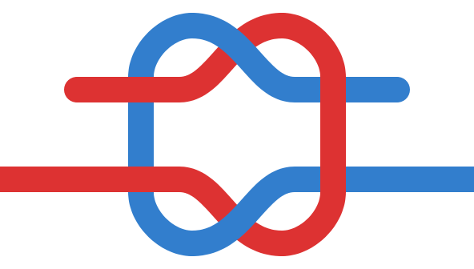  Sheet bend

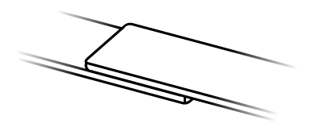  In-line lashing step 1 | 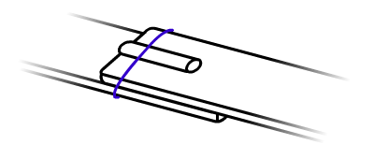  In-line lashing step 2
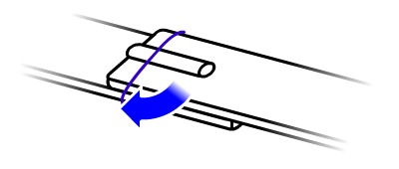  In-line lashing step 3 | 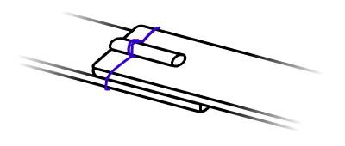  In-line lashing step 4
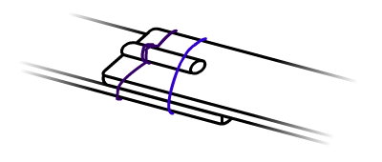  In-line lashing step 5 | 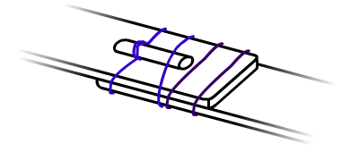  In-line lashing finished (repeated on other side)

