Exercise ASSEMBLE
    - Pre-requisites. This is an indoor, first-class cadet consolidation exercise, requiring the full teaching of the following subjects:
      - Radio communications
      - Map reading
    - Time. 1 x 40 minute period
    - Personnel.
      - Cadets. Two or more cadets, split into equal teams
      - DS. At least one CFAV or Cdt SNCO to act as exercise controller (EXCON).
    - References. Nil
    - Dress. Uniform of the day
    - Stores.
      - The two team maps provided below.
      - Radios
    - Revision.
      - Grid references (from map reading)
      - Correct VP for transmitting location across the radio
    - Conduct. This exercise can be carried out in a number of ways, based on the time available and the skill of the cadets, listed starting with the simplest/shortest:
      - With the cadets in two teams each with one map, have them list a set number of differences between the two maps.
      - With the cadets in two teams each with one map, have them list all of the differences between the two maps.
      - With the cadets in two teams each with one map, have them draw one full and correct map.
      - With the cadets in two teams each with one map, have each team draw a full and correct map.
      - With the cadets in three teams – two of the teams to have one map each, the other without – have the team with no map draw a full and correct map

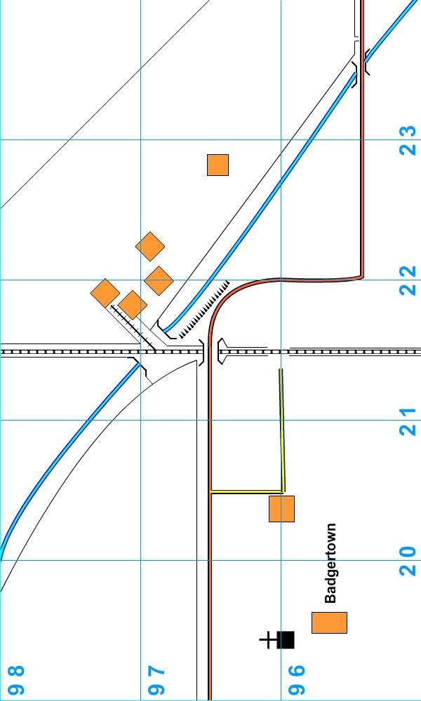
Team 1 Map
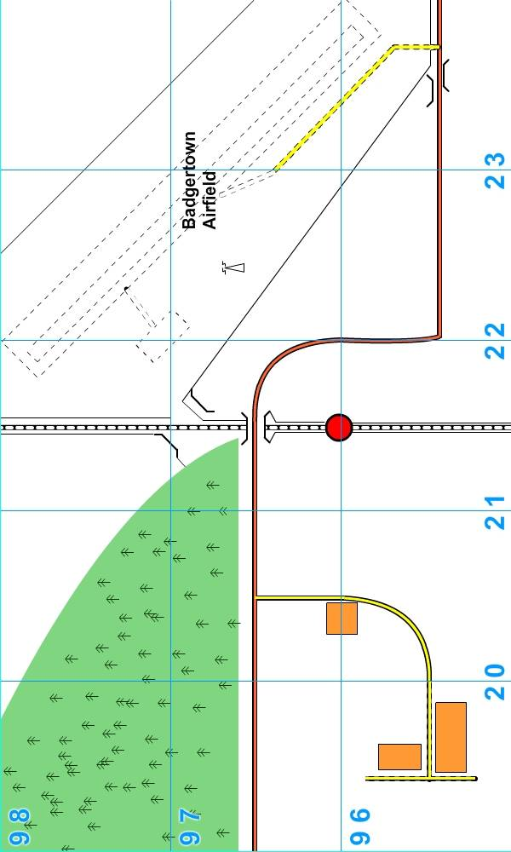
Team 2 Map
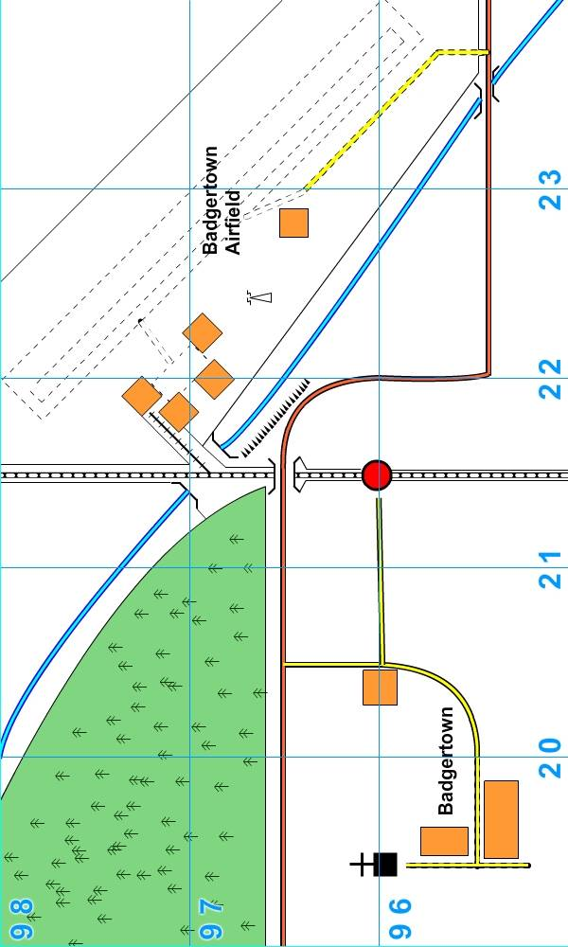
Full Map

