1st Class Cadet Workbook - Rhum Map
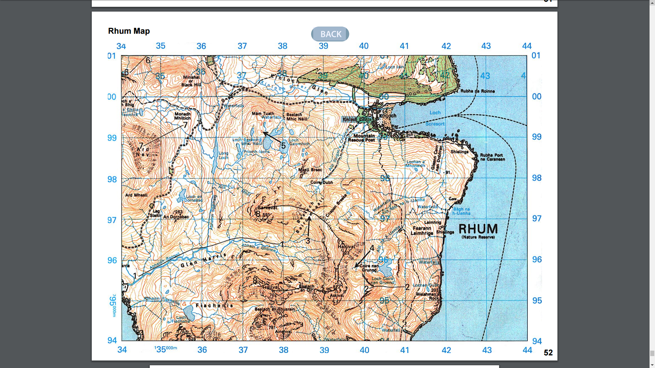
1
1
2
2
3
4
5
6
6
7
7
8
8

1st Class Cadet Workbook – Potters Bar Map
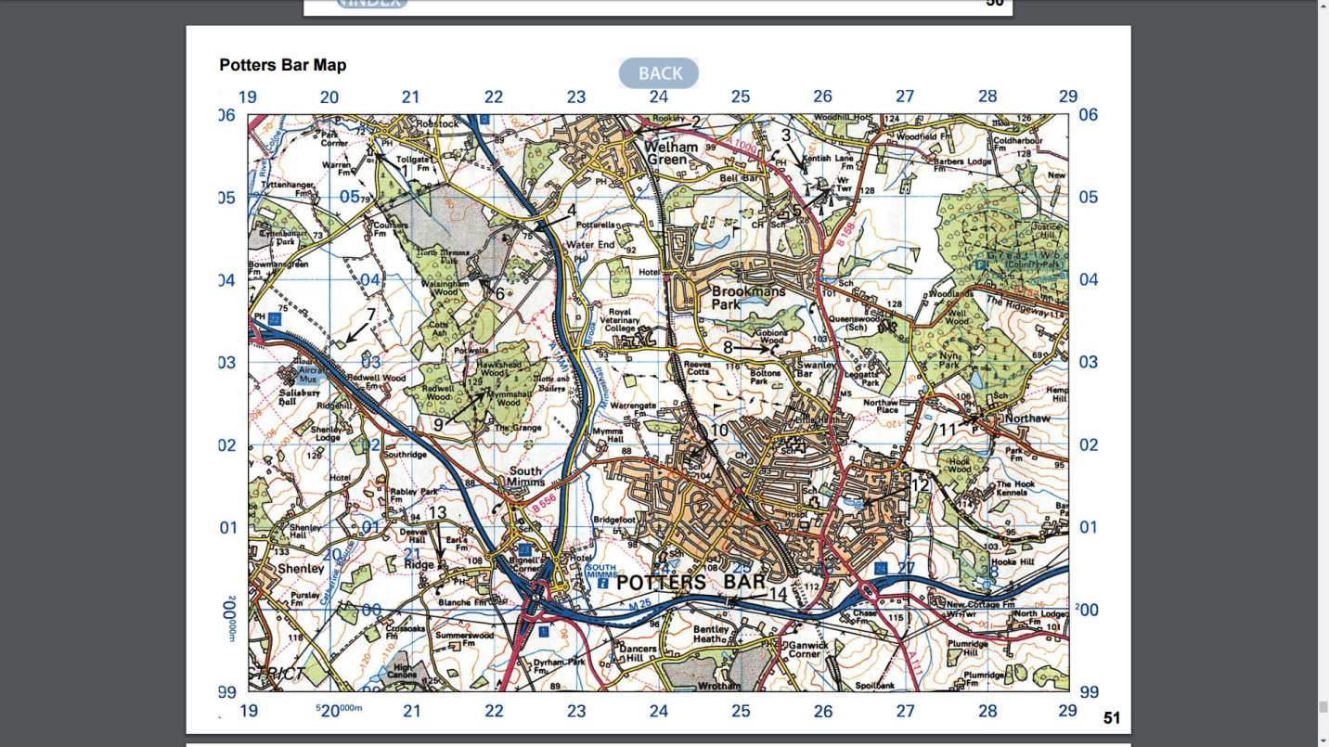
6
1
7
4
3
8
10
9
13
14
12
11
5
2

