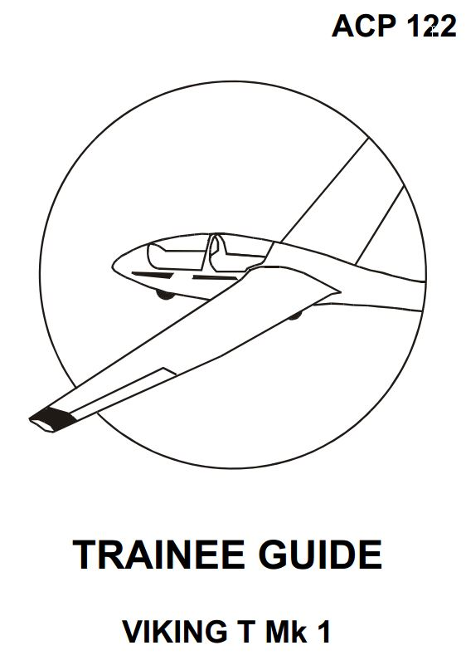
Foreword
This course has been adapted from ACP 122 Edition 5 ©2007.
It should be used as a guide for all lessons taught on the flight simulator, referencing to the ACP.
All instructors of this course must have a comprehensive knowledge of the course in order to instruct.

Table of Contents

Lesson 1 | Effects of Controls - 1
Lesson 2 | Effects of Controls - 2
Lesson 3 | Straight Glide
Lesson 4 | Winch Launch
Lesson 5 | Medium Turns
Lesson 6 | Approach and Landing
Lesson 7 | Stalling
Lesson 8 | Circuits - 1
Lesson 9 | Circuits - 2
Lesson 10 | Launch Failures
Lesson 11 | Pre Solo Check & First  Solo

