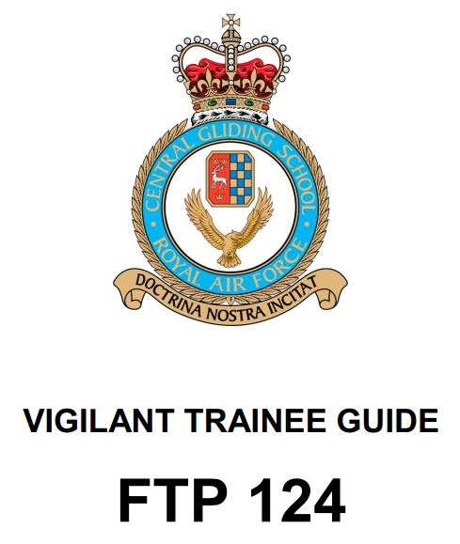
Foreword
This course has been adapted from FTP 124 Issue 1 ©2011.
It should be used as a guide for all lessons taught on the flight simulator, referencing to the FTP.
All instructors of this course must have a comprehensive knowledge of the course in order to instruct.

Table of Contents

Lesson 1 | Effects of Controls - 1
Lesson 2 | Effects of Controls - 2
Lesson 3 | Straight & Level Flight, Climbing & Gliding
Lesson 4 | Take Off & Climb
Lesson 5 | Medium Turns
Lesson 6 | Approach and Landing I
Lesson 7 | Stalling
Lesson 8 | Circuits
Lesson 9 | Circuits – (800 ft or 1000 ft Rectangular)
Lesson 10 | Power Loss After Take Off (PLATO)
Lesson 11 | Pre Solo Check & First  Solo

