OPERATIONAL FLYING – CARD GAME REVISION SESSION
      - Time. 1 x 40 minute period
      - References. Nil
      - Stores. The cards provided
      - Preparation. Set up tables so that the class is divided in to two or more teams (two or three cadets per team), seated around the table in a typical card-game fashion.
      - Revision. Types of Air Combat Operations and Combat Support Air Operations.

Conduct
      - The cards are to be laid out on the table, with the picture-side upwards.
      - Each team is to take it in turns to pick a card, stating what role the aircraft/missile can be used for – if correct, they may put the card into their ownership.
      - Upon successfully selecting a card, the cadet may also state a weapon that can be used by that aircraft, in the role stated (e.g. TORNADO – Battlefield Air Interdiction –BRIMSTONE) and if correct may move that card into their pile too.
      - Cadets may not pick a role that they have already collected a card for (e.g. if they have already selected APACHE for Close Air Support then they may not choose TORNADO too – however they may still choose Air Interdiction in order to collect the TORNADO, assuming they’ve not used it for any other aircraft)
      - The game finishes when neither team can make a further move (the instructor should of course make hints in order to maximise the teaching potential) – for one of the following reasons:
        - The team has filled every single role (these are listed below for convenience)
        - The team can’t think of any more roles
        - The team can’t think of any aircraft to fill remaining roles
        - The only aircraft/missiles left to the team cannot be used for the roles that the team have not been able to fill
      - If one team can still make moves whilst the other team is unable to, they may continue to move until they can no longer go.
      - The team with the greatest number of cards at the end of the session is the winner.
      - In order to make sure that everyone in the team is included, each member of the team is to make their own move (in turn) without conferring with the rest of the team.

List of Roles
      - Combat Air Operations
        - Counter Air
          - Offensive Counter Air
            - Fighter Sweep
            - Escort
            - Airfield Attack
            - Suppression of Enemy Air Defences
          - Defensive Counter Air
        - Anti-surface Operations
          - Tactical
            - Land-based
Air Interdiction
Battlefield Air Interdiction
Close Air Support
            - Maritime Air Operations
          - Strategic
      - Combat Support Air Operations
        - Transport
          - Scheduled Services
          - Airborne Operations
          - Air Logistic Operations
          - Aeromedical Evacuation
          - Special Air Operations
        - Air-to-air Refuelling
        - Search and Rescue
        - Electronic Warfare

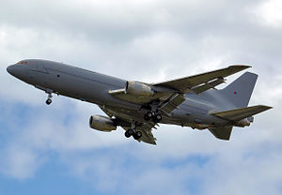

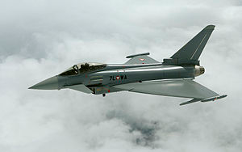
TYPHOON
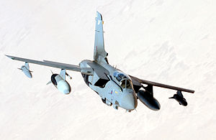
TORNADO
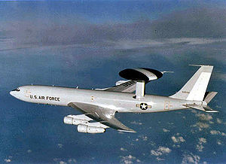
SENTRY
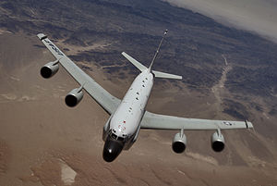
AIRSEEKER
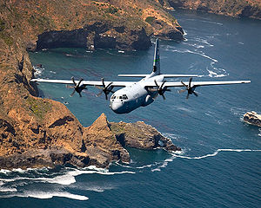
HERCULES
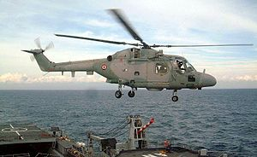
LYNX HAS
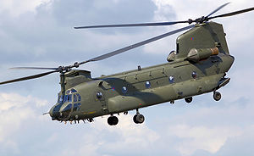
CHINOOK
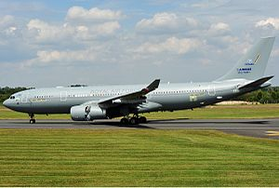
VOYAGER

LYNX HAS
- Maritime air operations
- Search and rescue
CHINOOK
- Transport
  - Airborne operations
  - Air Logistics
  - Special air operations
VOYAGER
- Transport
  - Scheduled
  - Aerial logistics
  - Aeromed
- AAR

SENTRY
- Reconnaissance
- Defensive counter air (active air defence) - detection
AIRSEEKER
(Rivet Joint)
- Reconnaissance
- Electronic Warfare

HERCULES
- Transport
  - Airborne operations
  - Scheduled services
  - Air Logistics
  - Special air operations
  - Aeromed

TYPHOON
- Tactical strike
  - BAI
  - AI
- Strategic strike
- Reconnaissance
- Offensive counter Air (all types)
- Defensive counter Air (active air defence) – weapon system
TORNADO
- Tactical strike
  - CAS
  - BAI
  - AI
- Strategic strike
- Reconnaissance
- Offensive counter Air
  - SEAD
  - Airfield Attack

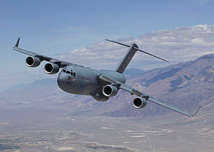
C-17
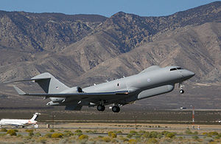
SENTINEL
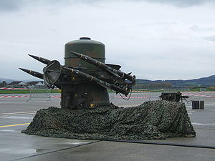
RAPIER
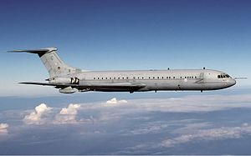

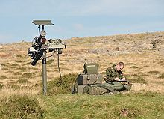
HVM
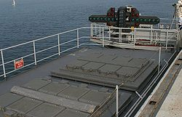
ASTER
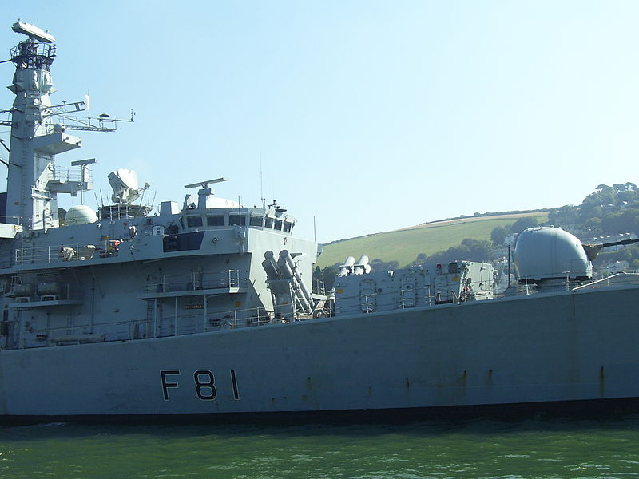
SEA WOLF
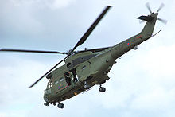
PUMA
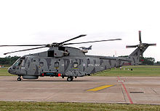
MERLIN HM

SEA WOLF
- Defensive counter Air (active air defence) – weapon system
PUMA
- Transport
  - Airborne operations
  - Air Logistics
- Special air operations
MERLIN HM
- Maritime air operations
- Search and rescue

HVM
- Defensive counter Air (active air defence) – weapon system
ASTER
- Defensive counter Air (active air defence) – weapon system

C-17
- Transport
  - Airborne operations
  - Scheduled services
  - Air Logistics
  - Special air operations
  - Aeromed
SENTINEL
- Reconnaissance
RAPIER
- Defensive counter Air (active air defence) – weapon system

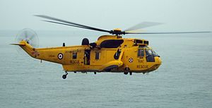
SEA KING HAR
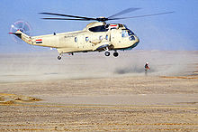
SEA KING HC
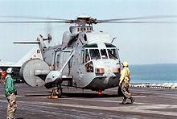
SEA KING ASaC
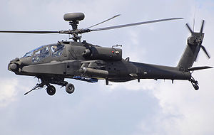
APACHE
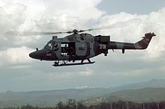
LYNX AH
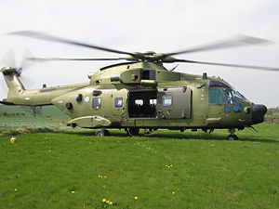
MERLIN HC
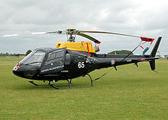
SQUIRREL
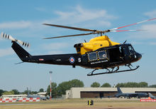
GRIFFIN
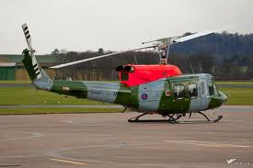
212

SQUIRREL
- Trainer
GRIFFIN
- Search and rescue
- Trainer
212
- Search and rescue
- Transport
  - Airborne operations

APACHE
- Tactical strike
  - CAS
  - BAI
  - AI
LYNX AH
- Transport
  - Airborne operations
  - Air Logistics
  - Special air operations
MERLIN HC
- Transport
  - Airborne operations
  - Air Logistics
  - Special air operations

SEA KING HAR
- Search and rescue
SEA KING HC
- Transport
  - Airborne operations
  - Air Logistics
  - Special air operations
SEA KING ASaC
- Reconnaissance
- Defensive counter air (active air defence) - detection

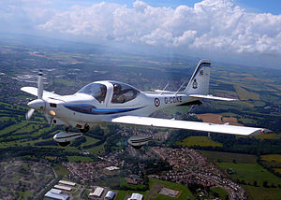
TUTOR
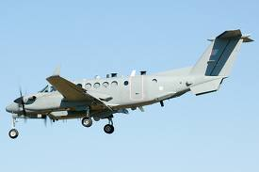
SHADOW
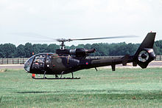
GAZELLE
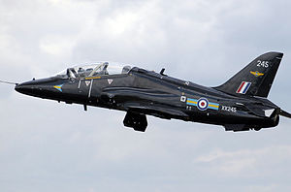
HAWK
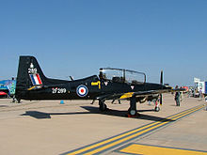
TUCANO
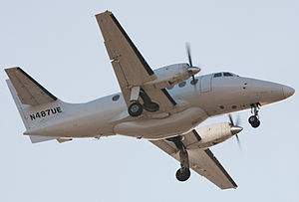
JETSTREAM

TUCANO
- Trainer
JETSTREAM
- Trainer

GAZELLE
- Reconnaissance
HAWK
- Trainer

TUTOR
- Trainer
SHADOW
- Reconnaissance (probably!)

Aircraft Weapons
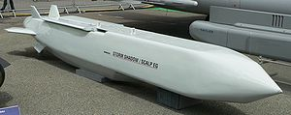  STORM SHADOW | 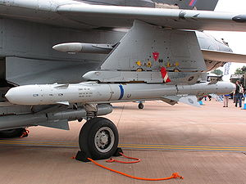  ALARM | 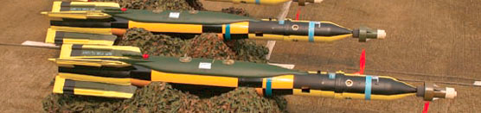  PAVEWAY
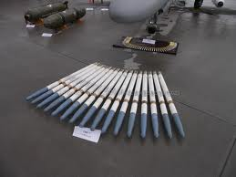  CVR-7 Rocket | 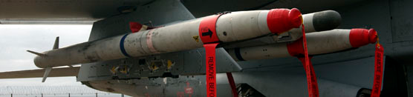  ASRAAM | 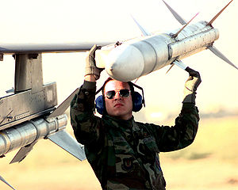  AMRAAM
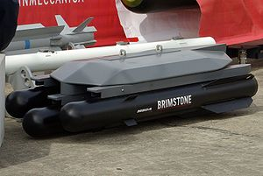  BRIMSTONE | 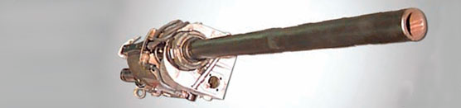  Mauser Cannon | 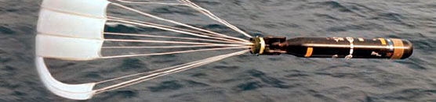  STINGRAY
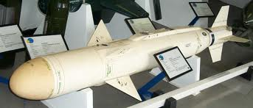  SEA SKUA | 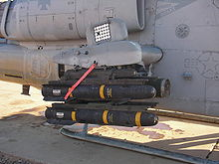  HELLFIRE | 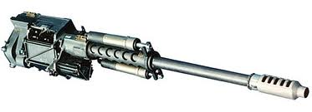  Chain Gun
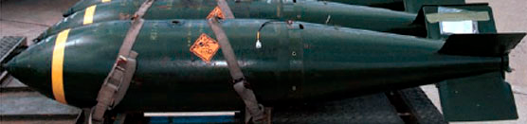
General-purpose Bomb

